**PROTOCOL v1.0 *Sep 22, 2020***

**STUDY TITLE: “Angio-based Quantitative flow ratio Virtual PCI versus Conventional Angio-guided PCI in the achievement of an optimal post-PCI QFR the AQVA trial”**

**BACKGROUND**

***Post-PCI physiology***

The results of functional assessment performed after percutaneous coronary intervention (PCI) taught us that a “successful” angiography-guided PCI is often suboptimal in terms of physiology and that physiology result after PCI is closely linked to outcome1, 2. Yet, post-PCI physiology is rarely utilized in clinical practice, being employed in less than 10% of lesions investigated with physiology pre-PCI3 Reasons for the low use of functional assessment post-PCI and for subsequent intervention are manifold. First, physiology is actually used after PCI only in cases where it was utilized pre-PCI. Second, randomized clinical trials (RCT) addressing the use of physiology to assess PCI results have not been performed, therefore clear instructions and cutoffs for its use are lacking. Third, when fractional flow reserve (FFR) is measured, the need to administer adenosine several times during the same procedure results in increased procedure time, cost and adverse side effects. Fourth, in case of a post-PCI suboptimal functional result, it may be difficult to ascertain the underlying cause.

New indices and tools have been developed in an effort to overcome barriers to the widespread adoption of functional assessment. Non-hyperaemic pressure indices (NHPI) including, resting distal to aortic coronary pressure ratio (Pd/Pa), and other resting indices have enabled functional evaluation without pharmacological arteriolar vasodilation, while angiography-based functional assessment (quantitative flow ratio [QFR], FFRangio, and vessel FFR [vFFR]) have eliminated the need for a dedicated pressure wire.

Importantly, these newer tools may allow operators to understand the mechanism underlying an abnormal physiology value after angiographically successful intervention. In fact, the real novelty related to their development is the shift from a binary interpretation of physiology (positive/negative) to a quantitative site-specific one. For these reasons, they are extremely appealing post-PCI and several studies have been recently conducted to validate them in this setting.

***QFR***

In particular, quantitative flow ratio (QFR) is an angiographically-derived estimate of FFR developed as an alternative to wire-based intracoronary physiology. One advantage of angio-based FFR systems is allowing the generation of a pullback curve and discrimination of the physiological contribution of each single lesion as well as diagnosis of diffuse disease. The value of QFR to assess the functional results of PCI has been tested in the prospective HAWKEYE (Angio-Based Fractional Flow Reserve to Predict Adverse Events After Stent Implantation) study. Seven hundred fifty-one vessels in 602 patients undergoing angiographically satisfactory second-generation DES implantation were analyzed1 At the end of the procedure, the operator acquired projections for QFR computation performed offline by an independent core laboratory. ROC curve analysis identified a post-PCI QFR best cut-off of <0.90 (area under the curve 0.77; 95% CI: 0.74-0.80; p< 0.001). After correction for potential confounding factors, post-PCI QFR<0.90 was associated with a 3-fold increase in risk for the vessel-oriented composite endpoint at 2 years (HR: 2.91; 95% CI 1.63-5.19; p< 0.001). Further, a very important finding of the HAWKEYE study was the demonstration that QFR could discriminate among different CAD patterns. In vessels with suboptimal functional result, the site of the QFR drop was in-stent in 13% of the cases, while a focal drop outside the stent was identifiable in 32% of the cases. Thirty-four percent of vessels showed diffuse disease, while in 21% a combination of the aforementioned possibilities was present. It is important to note that QFR analyzability depends on quality of angiography and it is feasible in around 80% of the cases1. Moreover, QFR is not applicable in specific lesion subsets such as left main, bifurcation and ostial lesions.

***Virtual PCI***

The inherent limit of post-PCI physiology is to add measurement and consequent actions after the end of a procedure that has been deemed successful by the same operator who is performing it. In addition, it is associated with the increase in procedural time and costs. Thus, a broad application of post-PCI physiology, although clinically meaningful, is implausible.

On the contrary, the systematic application of QFR before stenting to simulate PCI results according to different treatment strategies (virtual PCI) would be an interesting alternative to achieve a fully physiology guided procedure.

The advantages of a virtual PCI strategy based on QFR application are:

* QFR is a simple tool, based on what the operator already performs before PCI (namely two perpendicular angiographic projections) and not requiring wire or adenosine.
* It enables to obtain a full physiologic map of the vessel with a point-by-point detailed information of the functional impact of a given stenosis.
* It is possible to simulate the treatment of one or more lesions (virtual PCI) in order to estimate the final functional value post-PCI.

Then, virtual PCI based on QFR utilization would not increase procedural time or costs and could obtain an optimal post-PCI physiology result in most cases. The “Angio-based Quantitative flow ratio Virtual PCI versus Conventional Angio-guided PCI in the achievement of an optimal post-PCI QFR” (AQVA) trial is the first step toward this direction and will be the basis for a bigger study focused on hard clinical endpoints.

**STUDY RATIONALE**

A significant portion of patients continue to experience both adverse events and symptoms after angiographically successful PCI. Beyond different underlying mechanisms non-related to epicardial disease (vasospasm, microcirculatory dysfunction), several recent studies have shown that in at least 15-20% of PCIs, a prognostically meaningful ischemia, detected with different coronary physiology tools, is present at the end of a successful angiography-guided PCI. In addition, physiology is able to discriminate the underlying reason causing the suboptimal functional result, namely: i) in-stent drop; ii) focal drop outside stent; iii) diffuse disease.

However, the use of post-PCI physiology is still very low, even when it is utilized pre-PCI to set the indication for stenting. Lack of dedicated randomized clinical trials and procedural lengthening and increase in side effects are at the basis of this underutilization.

In addition, the ideal tool should allow to plan the intervention in advance rather than to assess the results afterwards. To this hand, QFR is particularly appealing, among available physiology tools, because it does not need wire or adenosine and allows: i) identification of disease mechanism; ii) co-registration with angiography; iii) pre-PCI planning with residual vessel QFR value according to a pre-specified treatment.

Taken all this characteristics together, QFR is the ideal technology for virtual PCI.

Our hypothesis is that a procedural planning based on QFR (virtual PCI) is able to reduce the rate of patients with post-PCI suboptimal functional result, that has been found to correlate with prognosis in our earlier study1, if compared to the traditional angio-guided PCI.

**STUDY FLOW CHART**

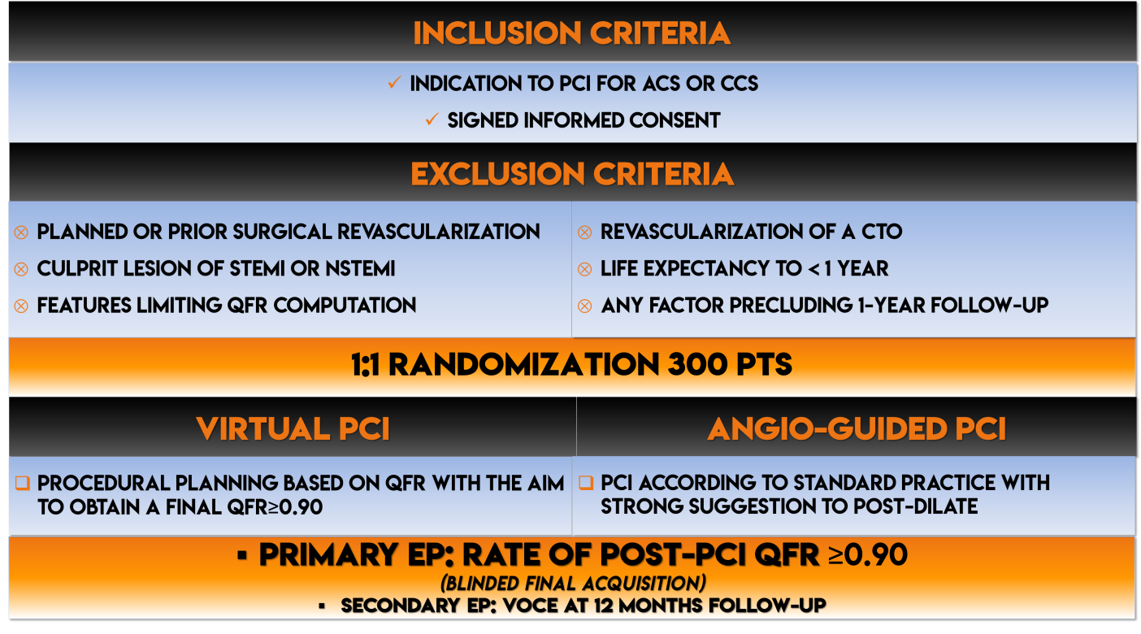

**OBJECTIVES**

To evaluate:

* The rate of lesions with a final post-PCI QFR≥0.90 in patients treated with the QFR virtual PCI versus patients treated with an angiography-based PCI.
* The rate of vessel-oriented composite endpoint (VOCE), defined as the composite of vessel-related cardiovascular death, vessel-related MI, and ischemia-driven target vessel revascularization (TVR)1, 4.

**ENDPOINTS**

The primary endpoint is defined as the proportion of patients with a final post-PCI QFR result ≥0.90.

The secondary endpoint is the rate of vessel-oriented composite endpoint (VOCE), defined as the composite of vessel-related cardiovascular death, vessel-related MI, and ischemia-driven target vessel revascularization (TVR)1, 4.

**INCLUSION AND EXCLUSION CRITERIA**

***Inclusion Criteria:***

1. Indication to PCI for either acute or chronic coronary syndrome
2. Signed informed consent

***Exclusion Criteria:***

1. Planned surgical revascularization
2. Prior Coronary Artery Bypass Graft (CABG) Surgery
3. Culprit lesion of STEMI or NSTEMI
4. Clinical or angiographic features limiting QFR computation:

left main or ostial right coronary artery

atrial fibrillation

ongoing ventricular arrhythmias

significant and persistent tachycardia

1. Revascularization of a chronic total occlusion
2. Non-cardiovascular co-morbidity reducing life expectancy to < 1 year
3. Any factor precluding 1-year follow-up

**STUDY PROCEDURES**

***Virtual PCI***

Before starting PCI, the operator must acquire QFR angiographic projections after nitroglycerin (100 to 200 mg) administration at 15 frames/second during a single injection of 6 ml radiographic contrast medium at a flow rate of 4 ml/s and a pressure of 300 psi using a power injector system. Angiographic projections should be at least 25 apart, aiming for minimal vessel foreshortening and minimal vessel overlap. In agreement with previous studies, operators follow a table of recommended projection angles1.

Afterwards, online QFR analysis must be performed. The tool “residual vessel QFR” should be used to anticipate the result of stenting (virtual PCI) by placing the proximal (p) and distal (d) marker in order to obtain a post-PCI QFR ≥0.90. then, the operator has to implant one or more stents following the pre-PCI plan and utilizing the QFR and angio co-registration tool to place the stent(s) according to the virtual PCI plan. Post-dilation with NC balloon is strongly suggested.

***Angiography-based PCI***

Invasive coronary angiography and PCI are performed following best local practices. Post-dilation with a noncompliant balloon is strongly suggested.

***Final blinded QFR projections***

At the end of the procedure, in both groups, 2 angiographic projections for each vessel treated with PCI are acquired for blinded QFR computation that will be performed in the central corelab located in Ferrara.

**SAMPLE SIZE CALCULATION**

In the HAWKEYE trial population, 16% of lesions presented a post-PCI QFR <0.90 after an angio-guided PCI1. In one third of these lesions, low post-PCI QFR was due to diffuse disease. Therefore, we can hypothesize that a procedural plan with QFR could be able to reduce the rate of lesions with QFR<0.90 by two thirds. Considering that some of the lesions with focal disease could also present diffuse disease, we can realistically estimate a reduction by 60% with virtual-PCI. Therefore, 300 patients are required to have a 80% chance of detecting, as significant at the 5% level, an increase in the percentage of patient achieving a post-PCI QFR≥0.90 from 84% in the angio-guided group to 94% in the virtual PCI group.

**References**

1. Biscaglia S, Tebaldi M, Brugaletta S, Cerrato E, Erriquez A, Passarini G, et al. Prognostic Value of QFR Measured Immediately After Successful Stent Implantation: The International Multicenter Prospective HAWKEYE Study. JACC Cardiovasc Interv 2019;12(20):2079-2088.

2. Jeremias A, Davies JE, Maehara A, Matsumura M, Schneider J, Tang K, et al. Blinded Physiological Assessment of Residual Ischemia After Successful Angiographic Percutaneous Coronary Intervention: The DEFINE PCI Study. JACC Cardiovasc Interv 2019;12(20):1991-2001.

3. Tebaldi M, Biscaglia S, Fineschi M, Musumeci G, Marchese A, Leone AM, et al. Evolving Routine Standards in Invasive Hemodynamic Assessment of Coronary Stenosis: The Nationwide Italian SICI-GISE Cross-Sectional ERIS Study. JACC Cardiovasc Interv 2018;11(15):1482-1491.

4. Piroth Z, Toth GG, Tonino PAL, Barbato E, Aghlmandi S, Curzen N, et al. Prognostic Value of Fractional Flow Reserve Measured Immediately After Drug-Eluting Stent Implantation. Circ Cardiovasc Interv 2017;10(8).